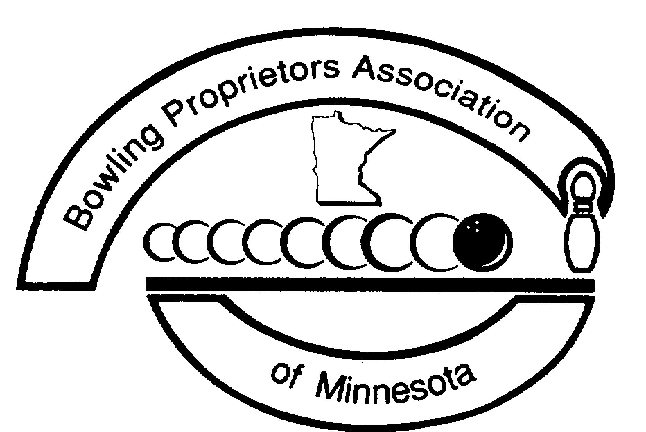
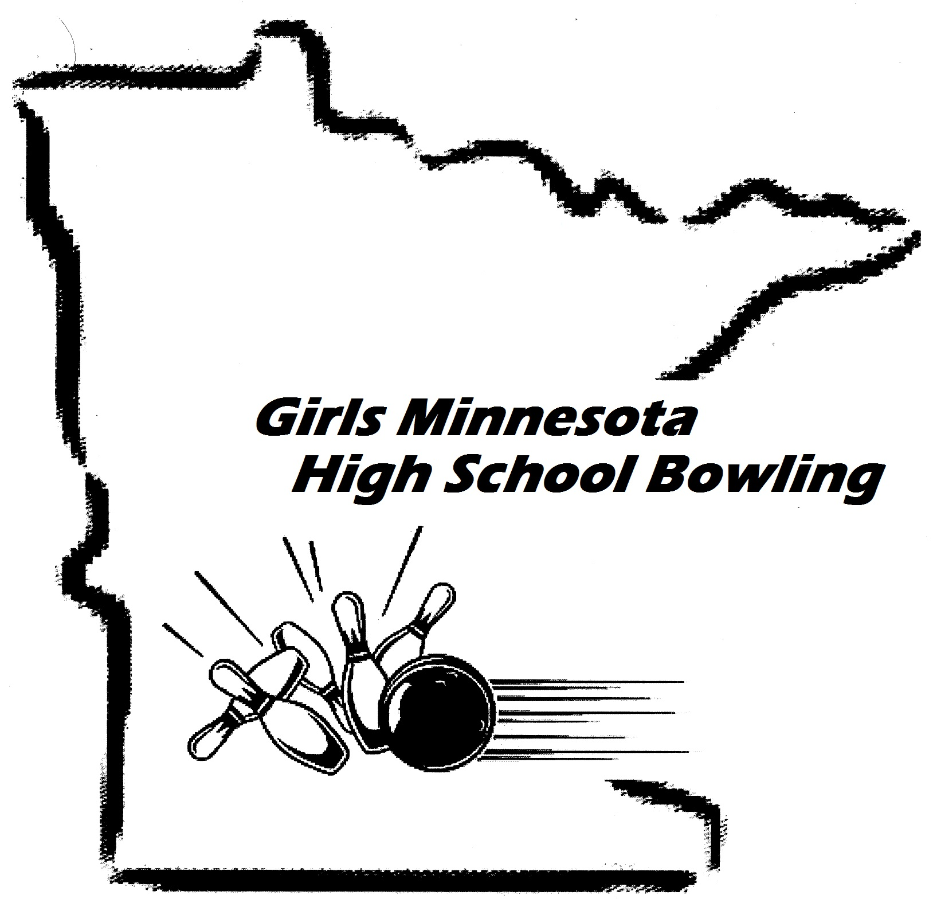
GMHSB 2019 PA-1

www.GoBowlingMinnesota.com

Girls Minnesota High School Bowling’s

request to pair two or more schools

A paired team consists of two or more high schools joining to become one team. The only justification for creating a paired team is that a single high school cannot provide enough bowlers to have its own team (at least 5 players). All teams wishing to be paired must apply for pairing by submitting this completed request form to the BPAM state office. All 2019 pairing requests should be reported to the BPAM state office no later than December 31, 2018. All students from a high school must bowl on the same team. Schools wishing to pair must make a reasonable attempt to pair with a team in a neighboring community. To preclude a state of “competitive disadvantage” the commissioners of Girls MHSB reserves the right to reject any proposed pairing.

Name of person making the application _______________________________________

Names of ALL schools wanting to pair:

___________________________________________________________ # of students from this school: _____

___________________________________________________________ # of students from this school: _____

___________________________________________________________ # of students from this school: _____

____________________________________________________________ # of students from this school: _____

____________________________________________________________ # of students from this school: _____

Sign below to acknowledge that your reason for wanting to pair these schools together is not to exclude bowlers of lesser ability from participating in Girls Minnesota High School Bowling and/or to create a “Super Team.”

------------------------------------------------------------------------------------------

Date signed _________________________________________

Fax or mail this form to:
Josh Hodney, BPAM
2418 - 123rd Court NE
Blaine, MN 55449
Fax: 763-755-0805

Call with questions: 763-755-2552 or 1-800-622-7769 Email: josh@mhsb.org

