MHSB 2018 PA-1

www.mhsb.org
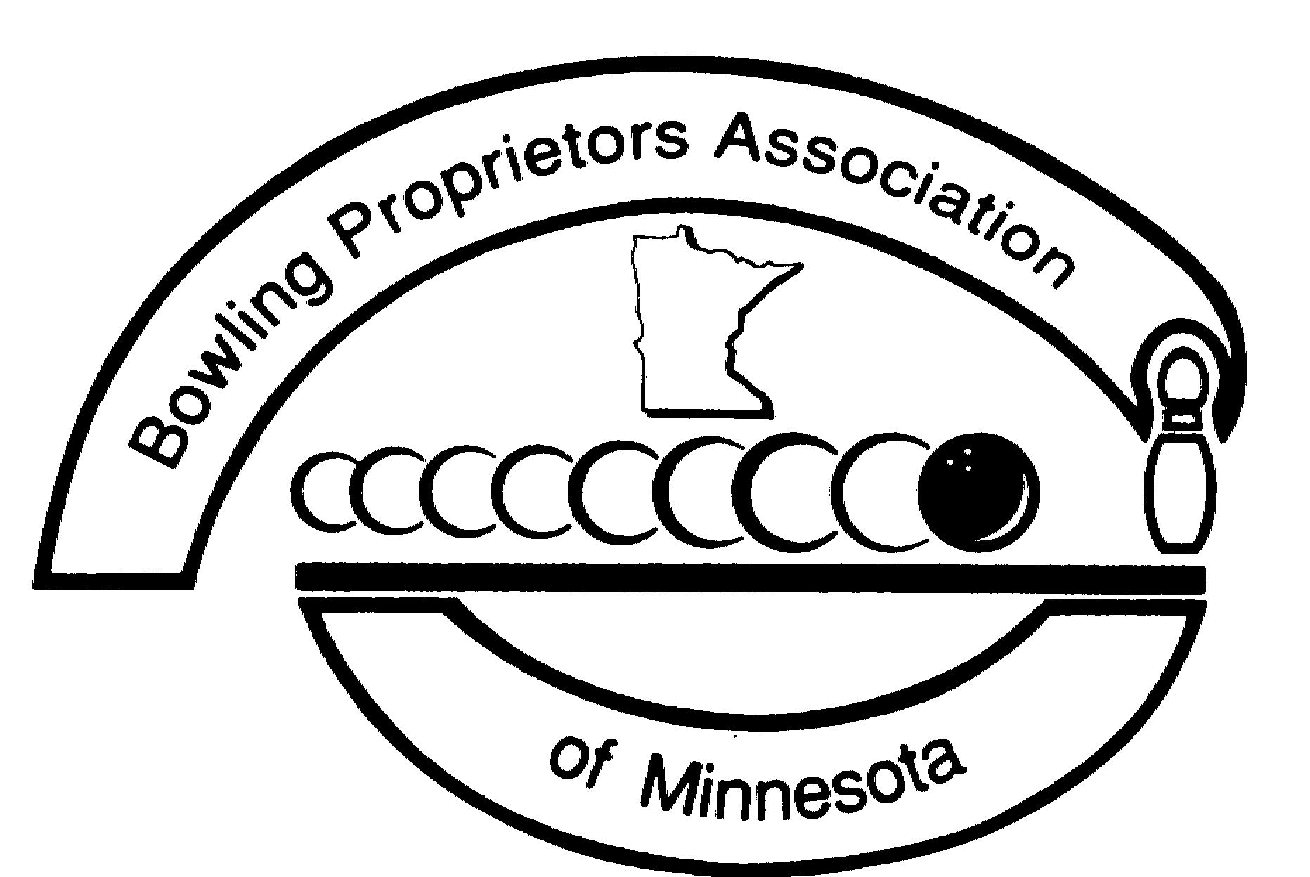

Minnesota High School Bowling’s

Request to pair two or more schools

A paired team consists of two or more high schools joining to become one team. The only justification for creating a paired team is that a single high school cannot provide enough bowlers to have its own team (at least 5 full-time players). All teams wishing to be paired must apply for pairing by submitting this completed request form to the BPAM state office. All 2018 pairing requests should be reported to the BPAM state office no later than August 15, 2018. All students from a high school must bowl on the same team. Schools wishing to pair must make a reasonable attempt to pair with a team in a neighboring community. To preclude a state of “competitive disadvantage” the commissions of MHSB reserves the right to reject any proposed pairing.

Name of person making the application _______________________________________

Names of ALL schools wanting to pair:

________________________________________________________ # of students from this school: _______

________________________________________________________ # of students from this school: _______

________________________________________________________ # of students from this school: _______

_________________________________________________________ # of students from this school: _______

_________________________________________________________ # of students from this school: _______

1.13b Bowlers that attend a charter school or private school
If a student attends a charter school or private school and his/her school fields a full bowling team then the student shall bowl for his/her school. If a student attends a charter school or private school and his/her school does not field a full bowling team then the student will bowl with a public school team (or a local charter or private school that fields a full team). The public high school boundary a charter/private school student resides in will determine what public high school a charter/private school student will bowl for. If there is no existing team in the district where a charter/private school student resides, then the MHSB commissioners will determine which existing team it is most appropriate for a charter/private school student to bowl with. Coaches may apply for exemptions if they feel that it is in the best interest of a team or student. Coaches wishing to apply for an exemption must do so by sending an email to the state office prior to September 1 of the current season. Commissioners will review and respond to all requests for exemptions.

Sign below to acknowledge that your reason for wanting to pair these schools together is not to exclude bowlers of lesser ability from participating in Minnesota High School Bowling and/or to create a “Super Team.”

------------------------------------------------------------------------------------------

Date signed _________________________________________

Fax, email, or mail this form to:
BPAM, 2418 - 123rd Court NE, Blaine, MN 55449
Fax: 763-755-0805 Email: josh@mhsb.org
Call with questions: 763-755-2552 or 1-800-622-7769

