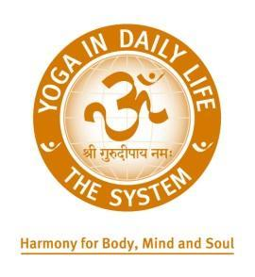

***Chakras Revealed***

***Hidden Powers in Humans***

***His Holiness Vishwaguru Paramhans Swami Maheshwarananda***

***Mt. Shasta, California***

***23-24 March, 2019***

We invite you to join Yoga in Daily Life for morning and evening workshops, talks and meditation. This weekend is intended for practitioners of yoga & spiritual aspirants and to provide a unique & valuable opportunity to learn from this renowned yoga Master. The retreat is going to take place in the vicinity of Mt. Shasta, a sacred mountain in Northern California that stands at the elevation of 14,180 feet and draws spiritual seekers from around the world, and in the town of Mt. Shasta.

**RETREAT DATES AND COST:**

Programme will include practical workshops, talks & meditation.

Saturday March 23rd 9am – Noon | 5pm – 8pm $40 | $80 with vegetarian lunch and dinner

Sunday March 24th 9am – Noon | 5pm – 8pm $40 | $80 with vegetarian lunch and dinner

**Registration for this retreat is required by Sunday, March 17th, 2019 by submitting your registration application to** [**bayarea@yogaindailylife.org**](mailto:bayarea@yogaindailylife.org)**.** If you do not register by this date we cannot guarantee you a place in the retreat and/or meals. To register and sign up for the retreat please email [bayarea@yogaindailylife.org](mailto:bayarea@yogaindailylife.org).

**Payment by cash on the first day of the retreat or by mailing a check to Alice Klosova; P.O. Box 818; Mt. Shasta CA 9606.**

**VENUE:**

The program will be held at Mt. Shasta City Park at the Lower Lodge.

Address: 1315 Nixon Road, Mt. Shasta, CA 96067

**LODGING OPTIONS IN MT. SHASTA:**

For lodging options, we recommend you use the website Visit Mt. Shasta at [www.visitmtshasta.com/lodging](http://www.visitmtshasta.com/lodging)

This will offer suggestions of Bed & Breakfasts, Hotels and Motels, Vacation Rentals or Resorts available in and around the town.

There are also homes for rent via Airbnb in Mt. Shasta. Please visit [www.airbnb.com/Mt.-Shasta-CA](http://www.airbnb.com/Mt.-Shasta-CA)

If the links above do not work, then please search via the Internet the names of the websites listed.

**GETTING TO MT. SHASTA:**

San Francisco International Airport (SFO) is approximately 288 miles (463 kilometers) from Mt. Shasta. It will take about 5 hours to travel by car.

Alternatively, there are 2 airports closer to Mt. Shasta that you can fly in to:

**1.Rogue Valley International Medford Airport in Medford, Oregon**: <http://jacksoncountyor.org/airport>

Medford Airport is 80 miles (130 kilometers) from Mt. Shasta and will take about 1 and a half hours by car. There are car rentals at the airport.

**2. Redding Municipal Airport in Redding, California:**

<https://www.cityofredding.org/departments/airports/redding-municipal-airport>

Redding Municipal Airport is 55 miles (89 kilometers) and will take about 1 hour. There are car rentals at the airport.

March is the end of the winter season in northern California, and we recommend you rent a car with all wheel drive for the journey should it snow. All participants in the seminar will be responsible for making their own travel arrangements to the town of Mt. Shasta.

**TERMS & CONDITIONS: Please read carefully**

* You will be responsible for making your own travel arrangements to the town of Mt. Shasta, and accommodation during the retreat.
* You will be responsible for having health and travel insurance for the retreat.
* Yoga in Daily Life – Bay Area cannot reserve a place in the seminar until a person has registered.
* Payment for the retreat will be due on the first day prior to the start of the retreat. The payment is non-refundable. Payment terms are by cash only.
* We reserve the right to make changes to the retreat program prior and during the retreat.

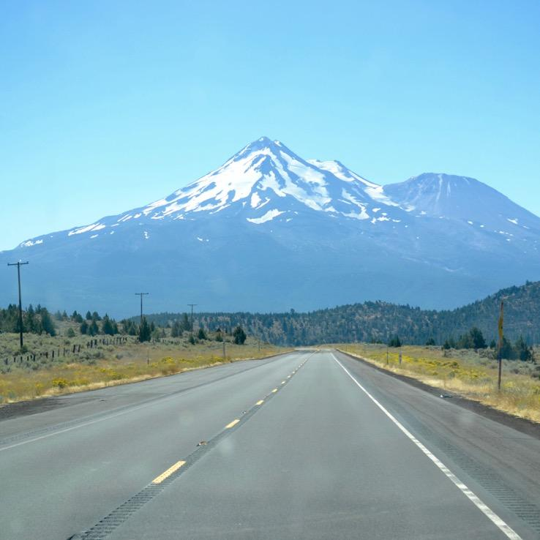

**WHAT TO BRING TO THE RETREAT:**

* comfortable and loose clothing for your yoga practice and meditation
* yoga mat
* warm clothing
* comfortable walking shoes for the snow

There will be satsang with Vishwaguruji on Monday March 25th from 7:30pm – 9pm at the Dashavatara Yoga Center. The address is 43271 Mission Boulevard, Fremont, CA 94539. Fremont is a town in the Bay Area and is about 32 miles from the San Francisco International Airport (SFO). A vegetarian meal will be served. Please use the Registration Form to register for this event to allow us to prepare for the dinner. There will be no charge to attend this event, but we kindly ask you make a donation to the Dashavatara Yoga Center.

**We welcome you, and hope you can join us for this time with Vishwaguruji in the beautiful and peaceful setting of Mt. Shasta.**